## Ideation Phase

**Brainstorm & Idea Prioritization Template**

|  |  |
| --- | --- |
| Date | 22 June 2025 |
| Team ID | LTVIP2025TMID30930 |
| Project Name | GARAGE MANAGEMENT SYSTEM |
| Maximum Marks | 4 Marks |

##### Brainstorm & Idea Prioritization Template:

Brainstorming provides a free and open environment that encourages everyone within a team to participate in the creative thinking process that leads to problem solving. Prioritizing volume over value, out-of-the-box ideas are welcome and built upon, and all participants are encouraged to collaborate, helping each other develop a rich amount of creative solutions.

Use this template in your own brainstorming sessions so your team can unleash their imagination and start shaping concepts even if you're not sitting in the same room.

Reference: <https://www.mural.co/templates/brainstorm-and-idea-prioritization>

##### Step-1: Team Gathering, Collaboration and Select the Problem Statement

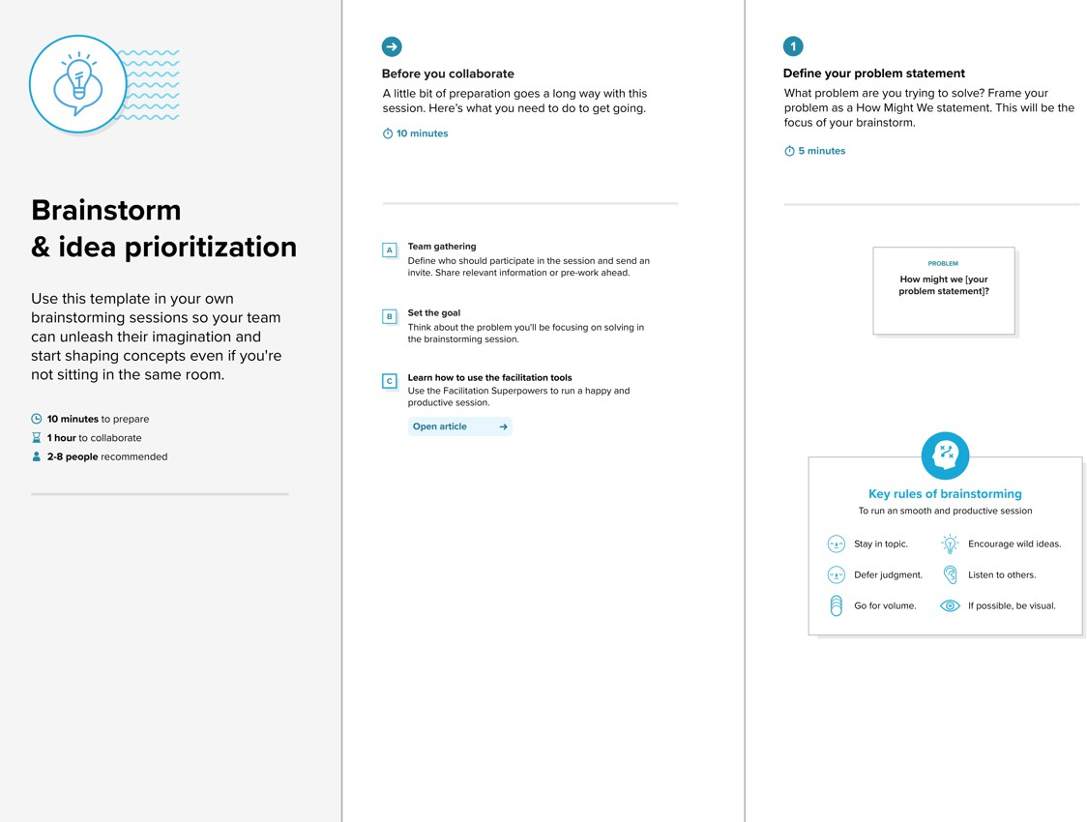

**Step-2: Brainstorm, Idea Listing and Grouping**

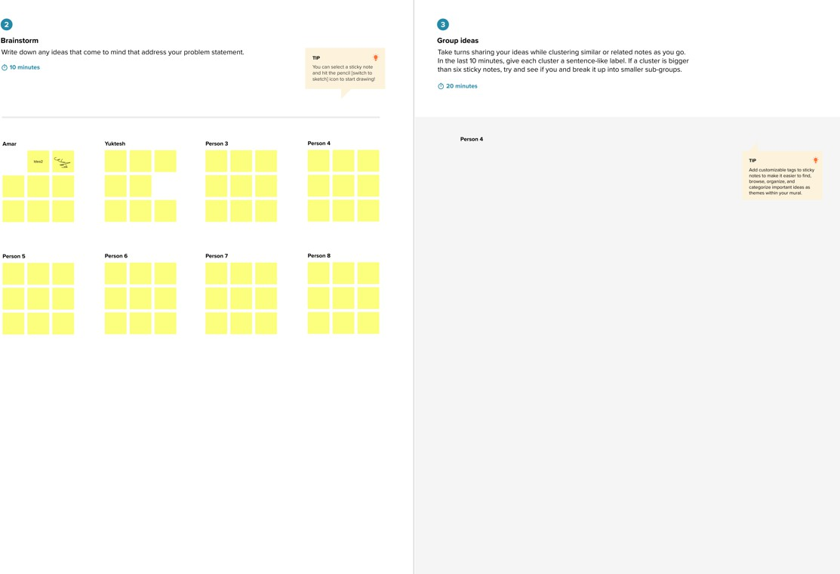

**Step-3: Idea Prioritization**

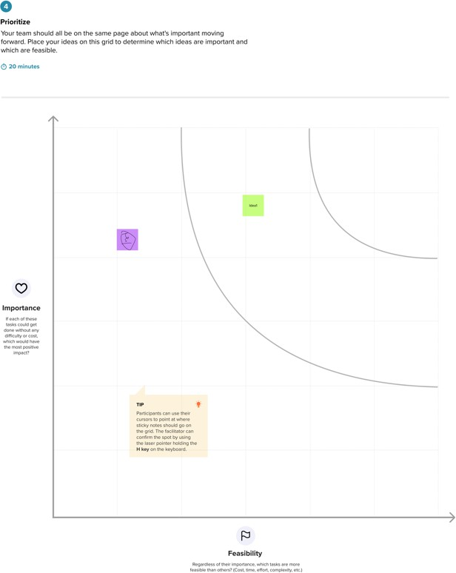

## Ideation Phase

**Brainstorm & Idea Prioritization Template**

|  |  |
| --- | --- |
| Date | 22 June 2025 |
| Team ID | LTVIP2025TMID30930 |
| Project Name | GARAGE MANAGEMENT SYSTEM |
| Maximum Marks | 4 Marks |

##### Brainstorm & Idea Prioritization Template:

Brainstorming provides a free and open environment that encourages everyone within a team to participate in the creative thinking process that leads to problem solving. Prioritizing volume over value, out-of-the-box ideas are welcome and built upon, and all participants are encouraged to collaborate, helping each other develop a rich amount of creative solutions.

Use this template in your own brainstorming sessions so your team can unleash their imagination and start shaping concepts even if you're not sitting in the same room.

Reference: <https://www.mural.co/templates/brainstorm-and-idea-prioritization>

##### Step-1: Team Gathering, Collaboration and Select the Problem Statement

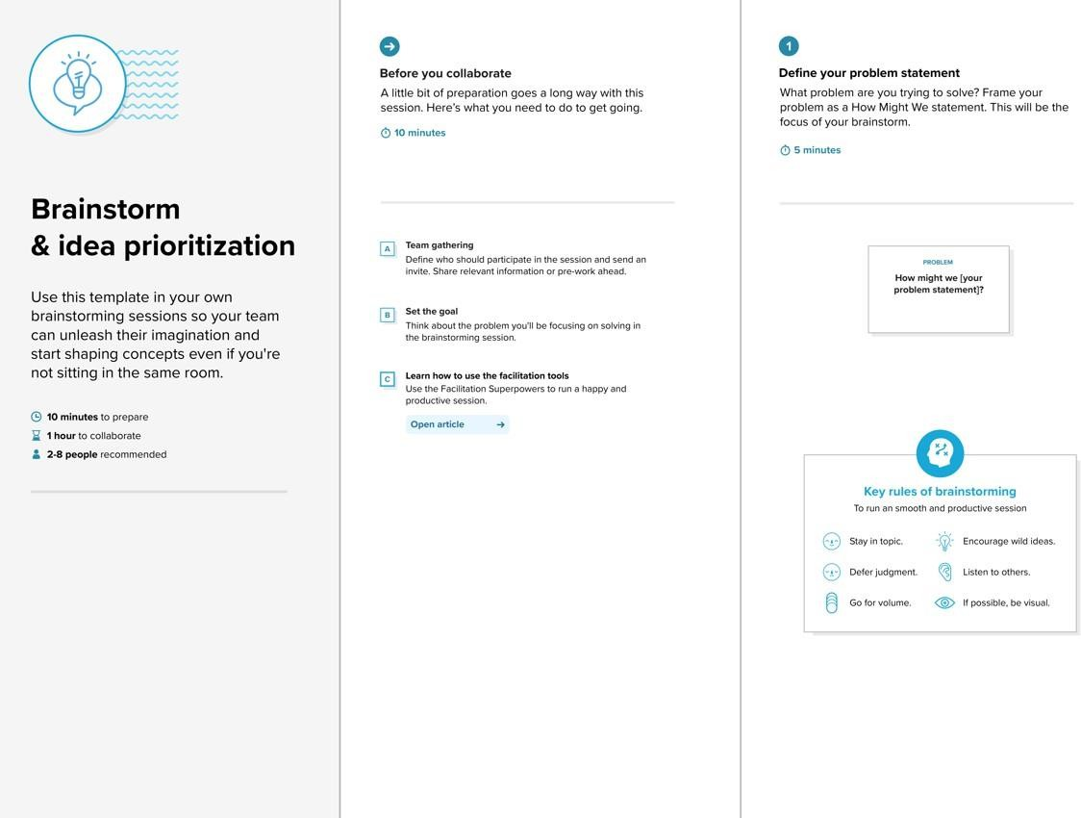

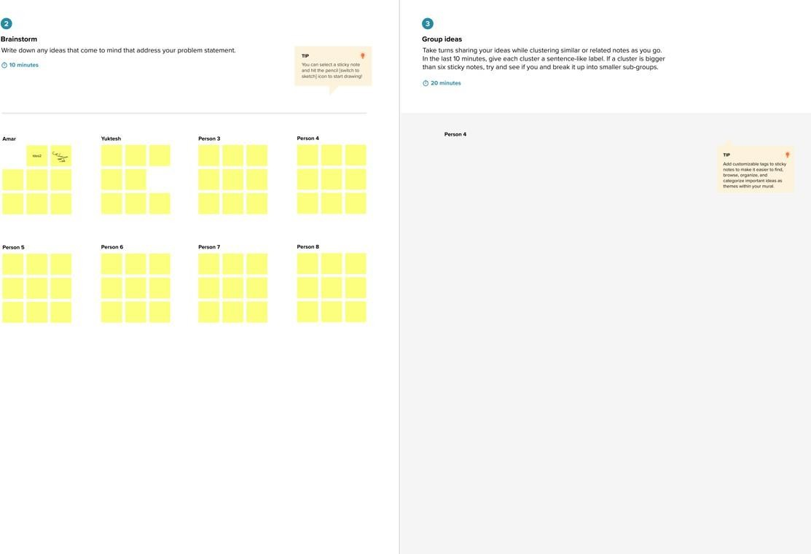**Step-2: Brainstorm, Idea Listing and Grouping**

**Step-3: Idea Prioritization**

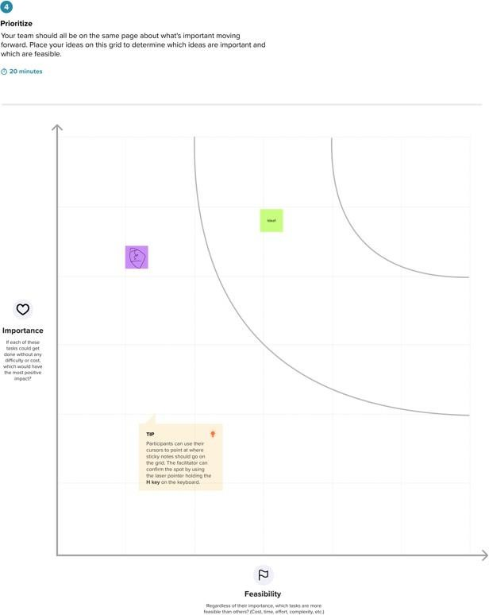

## Ideation Phase

**Define the Problem Statements**

|  |  |
| --- | --- |
| Date | 22 June 2025 |
| Team ID | LTVIP2025TMID30930 |
| Project Name | GARAGE MANAGEMENT SYSTEM |
| Maximum Marks | 2 Marks |

##### Customer Problem Statement Template:

Create a problem statement to understand your customer's point of view. The Customer Problem Statement template helps you focus on what matters to create experiences people will love.

A well-articulated customer problem statement allows you and your team to find the ideal solution for the challenges your customers face. Throughout the process, you’ll also be able to empathize with your customers, which helps you better understand how they perceive your product or service.

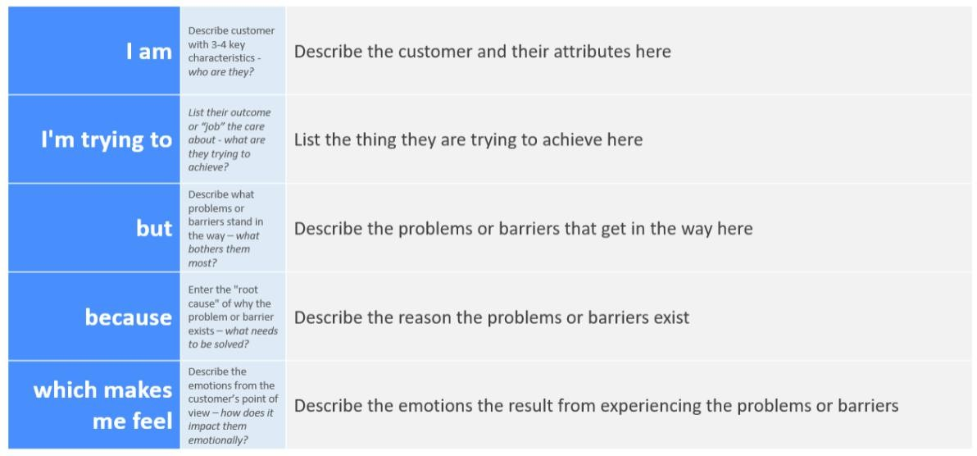

Reference: <https://miro.com/templates/customer-problem-statement/>

**Example:**



|  |  |  |  |  |  |
| --- | --- | --- | --- | --- | --- |
| **Problem Statement (PS)** | **I am (Customer)** | **I’m trying to** | **But** | **Because** | **Which makes me feel** |
| PS-1 |  |  |  |  |  |
| PS-2 |  |  |  |  |  |

## Ideation Phase

**Define the Problem Statements**

|  |  |
| --- | --- |
| Date | 22 June 2025 |
| Team ID | LTVIP2025TMID30930 |
| Project Name | GARAGE MANAGEMENT SYSTEM |
| Maximum Marks | 2 Marks |

##### Customer Problem Statement Template:

Create a problem statement to understand your customer's point of view. The Customer Problem Statement template helps you focus on what matters to create experiences people will love.

A well-articulated customer problem statement allows you and your team to find the ideal solution for the challenges your customers face. Throughout the process, you’ll also be able to empathize with your customers, which helps you better understand how they perceive your product or service.

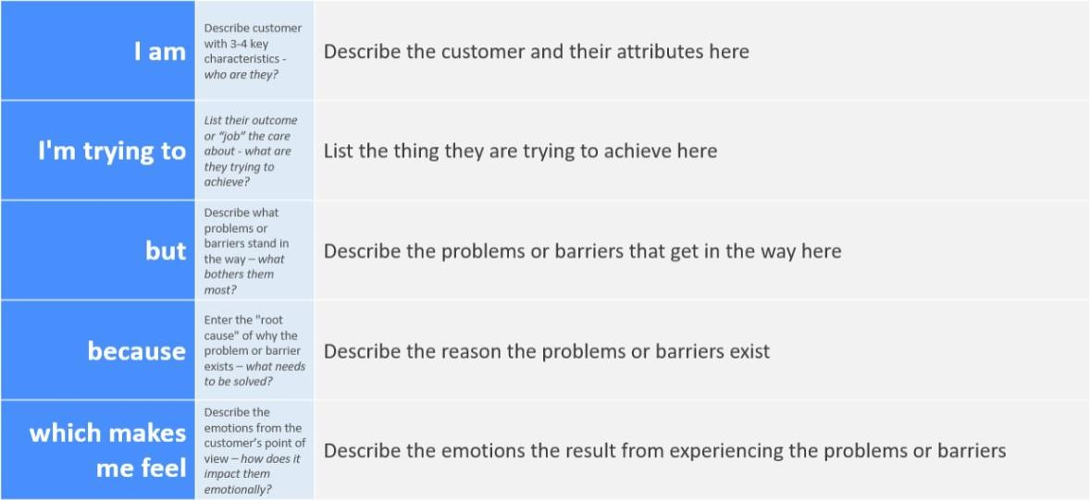

Reference: <https://miro.com/templates/customer-problem-statement/>

**Example:**

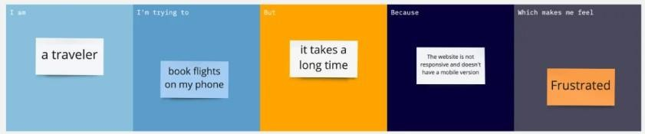

|  |  |  |  |  |  |
| --- | --- | --- | --- | --- | --- |
| **Problem Statement (PS)** | **I am (Customer)** | **I’m trying to** | **But** | **Because** | **Which makes me feel** |
| PS-1 |  |  |  |  |  |
| PS-2 |  |  |  |  |  |

## Ideation Phase Empathize & Discover

|  |  |
| --- | --- |
| Date | 22 June 2025 |
| Team ID | LTVIP2025TMID30930 |
| Project Name | GARAGE MANAGEMENT SYSTEM |
| Maximum Marks | 4 Marks |

##### Empathy Map Canvas:

An empathy map is a simple, easy-to-digest visual that captures knowledge about a user’s behaviours and attitudes.

It is a useful tool to helps teams better understand their users.

Creating an effective solution requires understanding the true problem and the person who is experiencing it. The exercise of creating the map helps participants consider things from the user’s perspective along with his or her goals and challenges.

**Example:**

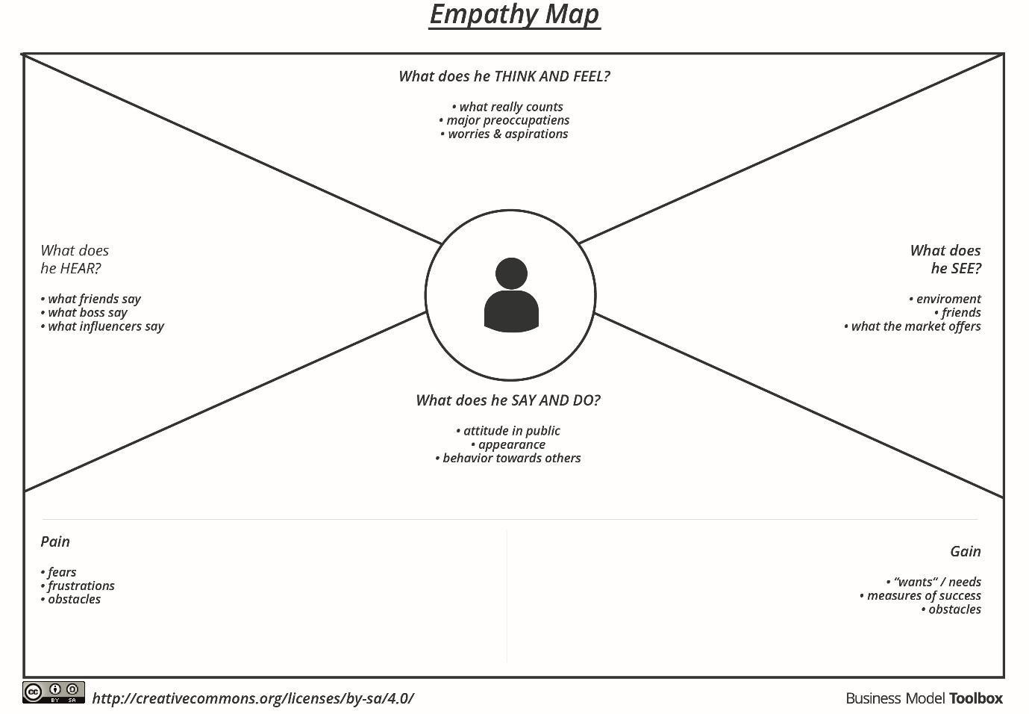

Reference: <https://www.mural.co/templates/empathy-map-canvas>

**Example: Food Ordering & Delivery Application**

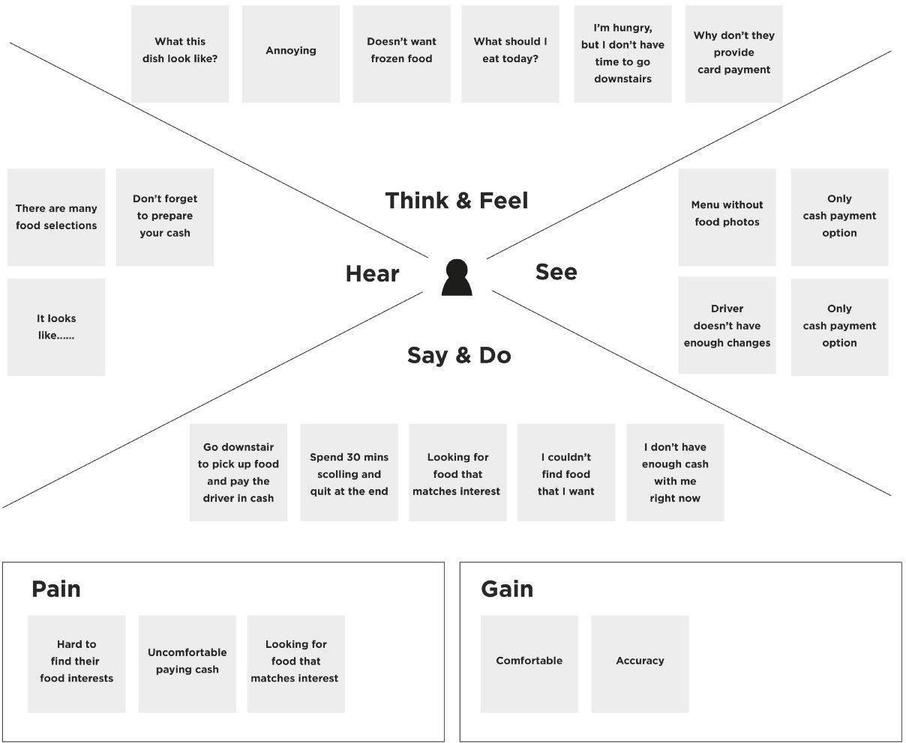

## Ideation Phase Empathize & Discover

|  |  |
| --- | --- |
| Date | 22 June 2025 |
| Team ID | LTVIP2025TMID30930 |
| Project Name | GARAGE MANAGEMENT SYSTEM |
| Maximum Marks | 4 Marks |

##### Empathy Map Canvas:

An empathy map is a simple, easy-to-digest visual that captures knowledge about a user’s behaviours and attitudes.

It is a useful tool to helps teams better understand their users.

Creating an effective solution requires understanding the true problem and the person who is experiencing it. The exercise of creating the map helps participants consider things from the user’s perspective along with his or her goals and challenges.

**Example:**



Reference: <https://www.mural.co/templates/empathy-map-canvas>

**Example: Food Ordering & Delivery Application**



## Ideation Phase Empathize & Discover

|  |  |
| --- | --- |
| Date | 22 June 2025 |
| Team ID | LTVIP2025TMID30930 |
| Project Name | GARAGE MANAGEMENT SYSTEM |
| Maximum Marks | 4 Marks |

##### Empathy Map Canvas:

An empathy map is a simple, easy-to-digest visual that captures knowledge about a user’s behaviours and attitudes.

It is a useful tool to helps teams better understand their users.

Creating an effective solution requires understanding the true problem and the person who is experiencing it. The exercise of creating the map helps participants consider things from the user’s perspective along with his or her goals and challenges.

**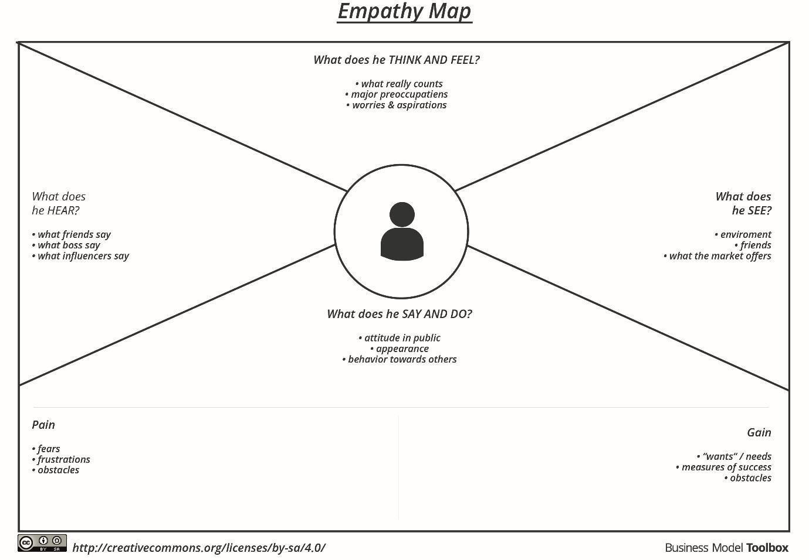****Example:**

Reference: <https://www.mural.co/templates/empathy-map-canvas>

**Example: Food Ordering & Delivery Application**

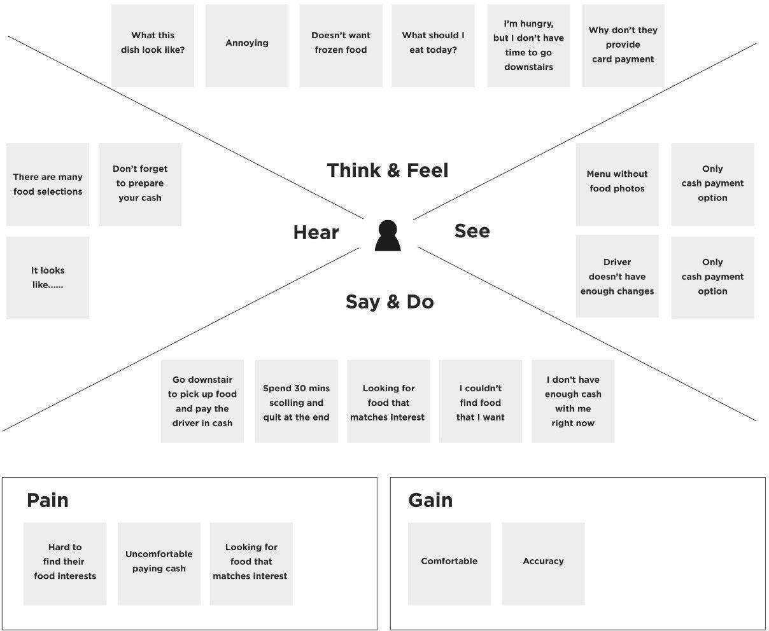

##### Project Development Phase Model Performance Test

|  |  |
| --- | --- |
| Date | 22 June 2025 |
| Team ID | LTVIP2025TMID30930 |
| Project Name | GARAGE MANAGEMENT SYSTEM |
| Maximum Marks | 4 |

**Model Performance Testing:**

Project team shall fill the following information in model performance testing template.

|  |  |  |  |
| --- | --- | --- | --- |
| **S.No.** | **Parameter** | **Values** | **Screenshot** |
| 1. | Model Summary | **-** |  |
| 2. | Accuracy | Training Accuracy -  Validation Accuracy - |  |
| 3. | Fine Tunning Result( if Done) | Validation Accuracy - |  |

##### Functional & Performance Testing Template

**Model Performance Test**

|  |  |
| --- | --- |
| Date | 22 June 2025 |
| Team ID | LTVIP2025TMID30930 |
| Project Name | GARAGE MANAGEMENT SYSTEM |
| Maximum Marks | 6 |

**Test Scenarios & Results**

|  |  |  |  |  |  |
| --- | --- | --- | --- | --- | --- |
| **Test Case ID** | **Scenario (What to test)** | **Test Steps (How to test)** | **Expected Result** | **Actual Result** | **Pass/Fail** |
| **FT-01** | Text Input Validation (e.g., topic, job title) | Enter valid and invalid text in input fields | Valid inputs accepted, errors for invalid inputs |  |  |
| **FT-02** | Number Input Validation (e.g., word count, size, rooms) | Enter numbers within and outside the valid range | Accepts valid values, shows error for out- of-range |  |  |
| **FT-03** | Content Generation (e.g., blog, resume, design idea) | Provide complete inputs and click "Generate" | Correct content is generated based on input |  |  |
| **FT-04** | API Connection Check | Check if API key is correct and model responds | API responds successfully |  |  |
| **PT-01** | Response Time Test | Use a timer to check content generation time | Should be under 3 seconds |  |  |
| **PT-02** | API Speed Test | Send multiple API calls at the same time | API should not slow down |  |  |

|  |  |  |  |  |  |
| --- | --- | --- | --- | --- | --- |
| **PT-03** | File Upload Load Test (e.g., PDFs) | Upload multiple PDFs and check processing | Should work smoothly without crashing |  |  |

**Project Development Phase Model Performance Test**

|  |  |
| --- | --- |
| Date | 22 June 2025 |
| Team ID | LTVIP2025TMID30930 |
| Project Name | GARAGE MANAGEMENT SYSTEM |
| Maximum Marks | 10 Marks |

**Model Performance Testing:**

Project team shall fill the following information in model performance testing template.

|  |  |  |  |
| --- | --- | --- | --- |
| **S.No.** | **Parameter** | **Values** | **Screenshot** |
| 1. | Metrics | **Regression Model:**  MAE - , MSE - , RMSE - , R2 score -  **Classification Model:**  Confusion Matrix - , Accuray Score-  & Classification Report - |  |
| 2. | Tune the Model | Hyperparameter Tuning - Validation Method - |  |

##### Project Development Phase Model Performance Test

|  |  |
| --- | --- |
| Date | 22 June 2025 |
| Team ID | LTVIP2025TMID30930 |
| Project Name | GARAGE MANAGEMENT SYSTEM |
| Maximum Marks | 10 |

**Model Performance Testing:**

Project team shall fill the following information in model performance testing template.

|  |  |  |
| --- | --- | --- |
| **S.No.** | **Parameter** | **Screenshot / Values** |
| 1. | Data Rendered |  |
| 2. | Data Preprocessing |  |
| 3. | Utilization of Data Filters |  |
| 4. | DAX Queries Used |  |
| 5. | Dashboard design | No of Visualizations / Graphs - |
| 6 | Report Design | No of Visualizations / Graphs - |

##### Project Development Phase Model Performance Test

|  |  |
| --- | --- |
| Date | 22 June 2025 |
| Team ID | LTVIP2025TMID30930 |
| Project Name | GARAGE MANAGEMENT SYSTEM |
| Maximum Marks | 10 |

**Model Performance Testing:**

Project team shall fill the following information in model performance testing template.

|  |  |  |  |
| --- | --- | --- | --- |
| **S.No.** | **Parameter** | **Values** | **Screenshot** |
| 1. | Model Summary | Salesforce automation setup for Data management using Object, Fields and Reports.  **Note :** Import Records if data Match Correctly then Records will Created or Else it will Show Error |  |
| 2. | Accuracy | Training Accuracy - 98% Validation Accuracy - 98% |  |
| 3. | Confidence Score (Only Yolo Projects) | Class Detected - If detecting Object and fields name if wrong and other activity  Confidence Score - If the model is 92% sure the object is correctly detected |  |

# User Acceptance Testing (UAT) Template

|  |  |
| --- | --- |
| Date | 22 June 2025 |
| Team ID | LTVIP2025TMID30930 |
| Project Name | GARAGE MANAGEMENT SYSTEM |
| Maximum Marks | 10 |

**Project Overview:**

Project Name: [Enter Project Name]

Project Description: [Brief Description of the Project] Project Version: [Version Number]

Testing Period: [Start Date] to [End Date]

**Testing Scope:**

[List of Features and Functionalities to be Tested] [List of User Stories or Requirements to be Tested] **Testing Environment:**

URL/Location: [Web URL or Application Location] Credentials (if required): [Username/Password] **Test Cases:**

|  |  |  |  |  |  |
| --- | --- | --- | --- | --- | --- |
| **Test Case ID** | **Test Scenario** | **Test Steps** | **Expected Result** | **Actual Result** | **Pass/Fail** |
| TC-001 | [Describe the scenario to be tested] | [Step 1]  [Step 2]  [Step 3] | [Describe the expected outcome] | [Record the actual outcome] | [Pass/Fail] |
| ... | ... | ... | ... | ... | ... |

**Bug Tracking:**

|  |  |  |  |  |  |
| --- | --- | --- | --- | --- | --- |
| **Bug ID** | **Bug Description** | **Steps to reproduce** | **Severity** | **Status** | **Additional feedback** |
| BG-001 | [Describe the issue or | [Step 1]  [Step 2] | [Low/Medi | [Open/In  Progress/ | [Any  additional |

|  |  |  |  |  |  |
| --- | --- | --- | --- | --- | --- |
|  | bug encountered  ] | [Step 3] | um/High] | Closed] | comments or feedback] |
| ... | ... | ... | ... | ... | ... |

**Sign-off:**

Tester Name: [Name of Tester] Date: [Date of Test Completion] Signature: [Tester's Signature] **Notes:**

* Ensure that all test cases cover both positive and negative scenarios.
* Encourage testers to provide detailed feedback, including any suggestions for improvement.
* Bug tracking should include details such as severity, status, and steps to reproduce.
* Obtain sign-off from both the project manager and product owner before proceeding with deployment.

##### Project Design Phase Problem – Solution Fit Template

|  |  |
| --- | --- |
| Date | 22 June 2025 |
| Team ID | LTVIP2025TMID30930 |
| Project Name | GARAGE MANAGEMENT SYSTEM |
| Maximum Marks | 2 Marks |

**Problem – Solution Fit Template:**

The Problem-Solution Fit simply means that you have found a problem with your customer and that the solution you have realized for it actually solves the customer’s problem. It helps entrepreneurs, marketers and corporate innovators identify behavioral patterns and recognize what would work and why

**Purpose:**

* Solve complex problems in a way that fits the state of your customers.
* Succeed faster and increase your solution adoption by tapping into existing mediums and channels of behavior.
* Sharpen your communication and marketing strategy with the right triggers and messaging.
* Increase touch-points with your company by finding the right problem-behavior fit and building trust by solving frequent annoyances, or urgent or costly problems.
* **Understand the existing situation in order to improve it for your target group.**

**Template:**

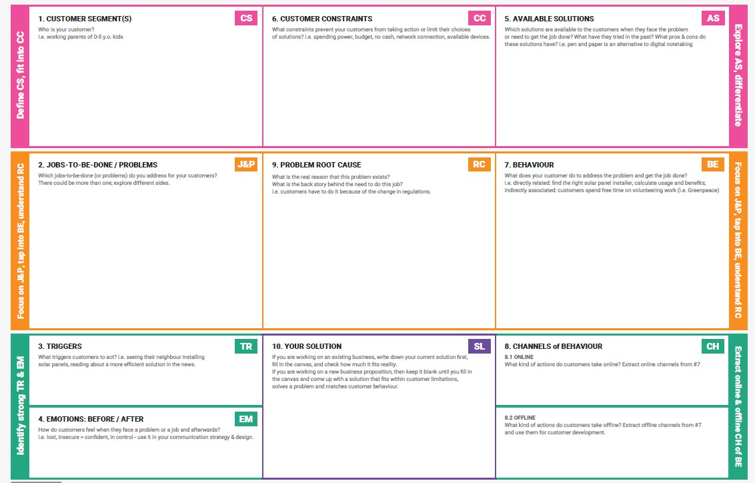

References:

1. <https://www.ideahackers.network/problem-solution-fit-canvas/>
2. [https://medium.com/@epicantus/problem-solution-fit-canvas-aa3dd59cb4fe](https://medium.com/%40epicantus/problem-solution-fit-canvas-aa3dd59cb4fe)





**5. AVAILABLE SOLUTIONS**

Which solutions are available to the customers when they face the problem

or need to get the job done? What have they tried in the past? What pros & cons do these solutions have? i.e. pen and paper is an alternative to digital notetaking

**6. CUSTOMER CC**

What constraints prevent your customers from taking action or limit their choices

of solutions? i.e. spending power, budget, no cash, network connection, available devices.

**CS**

**1. CUSTOMER SEGMENT(S)**

Who is your customer?

i.e. directly related: find the right solar panel installer, calculate usage and benefits; indirectly associated: customers spend free time on volunteering work (i.e. Greenpeace)

**BE**

**7. BEHAVIOUR**

What does your customer do to address the problem and get the job done?

**RC**

**9. PROBLEM ROOT CAUSE**

What is the real reason that this problem exists? What is the back story behind the need to do this job?

i.e. customers have to do it because of the change in regulations.

**J&P**

**2. JOBS-TO-BE-DONE / PROBLEMS**

Which jobs-to-be-done (or problems) do you address for your customers? There could be more than one; explore different sides.

**Explore AS, differentiate**

**Focus on J&P, tap into BE, understand RC**

**Define CS, fit into CC**

**Focus on J&P, tap into BE, understand RC**

Purpose / Vision

|  |  |  |  |  |
| --- | --- | --- | --- | --- |
| **Identify strong TR & EM** | **3. TRIGGERS TR**  What triggers customers to act? i.e. seeing their neighbour installing solar panels, reading about a more efficient solution in the news. | **10. YOUR SOLUTION SL**  If you are working on an existing business, write down your current solution first, fill in the canvas, and check how much it fits reality.  If you are working on a new business proposition, then keep it blank until you fill in the canvas and come up with a solution that fits within customer limitations, solves a problem and matches customer behaviour. | 1. **CHANNELS of BEHAVIOUR CH**     1. **ONLINE**   What kind of actions do customers take online? Extract online channels from #7 | **Extract online & offline CH of BE** |
| **4. EMOTIONS: BEFORE / AFTER EM**  How do customers feel when they face a problem or a job and afterwards?  i.e. lost, insecure > confident, in control - use it in your communication strategy & design. | **8.2 OFFLINE**  What kind of actions do customers take offline? Extract offline channels from #7 and use them for customer development. |

Problem-Solution it canvas is licensed under a Creative Commons Attribution-NonCommercial-NoDerivatives 4.0 license Created by Daria Nepriakhina / Amaltama.com

**A Sprint** fixed period or duration in which a team works to complete a set of tasks

An **Epic** is a **big task or project** that is too large to complete in one sprint. It is broken down into **smaller tasks (stories)** that can be completed over multiple sprints.

A **Story** is a small task . It is part of an **Epic**.

A **Story Point** is a number that represents how much effort a story takes to complete. (usually in form of Fibonacci series)

1. Very Easy task
2. Easy task
3. Moderate task

**5-** Difficult task

**Sprint 1: (5 Days)**

Data Collection

Collection of Data **2**

Loading Data **1**

Data Preprocessing

Handling Missing Values **3**

Handling Categorical values **2**

**Sprint 2 (5 Days)**

Model Building

Model Building **5**

Testing Model **3**

Deployment

Working HTML Pages **3**

Flask deployment **5**

**Total Story Points**

Sprint 1 = 8

Sprint 2 = 16

Velocity= Total Story Points Completed/ Number of Sprints Total story Points= 16+8 =24

No of Sprints= 2

**Velocity** = (16+8)/2= 24/2 12 (Story Points per Sprint)

**Your team’s velocity is 12 Story Points per Sprint.**

## Project Planning Phase

##### Project Planning Template (Product Backlog, Sprint Planning, Stories, Story points)

|  |  |
| --- | --- |
| Date | 22 June 2025 |
| Team ID | LTVIP2025TMID30930 |
| Project Name | GARAGE MANAGEMENT SYSTEM |
| Maximum Marks | 5 Marks |

**Product Backlog, Sprint Schedule, and Estimation (4 Marks)**

Use the below template to create product backlog and sprint schedule

|  |  |  |  |  |  |  |
| --- | --- | --- | --- | --- | --- | --- |
| **Sprint** | **Functional**  **Requirement (Epic)** | **User Story**  **Number** | **User Story / Task** | **Story Points** | **Priority** | **Team**  **Members** |
| Sprint-1 | Registration | USN-1 | As a user, I can register for the application by entering my email, password, and confirming my password. | 2 | High |  |
| Sprint-1 |  | USN-2 | As a user, I will receive confirmation email once I have registered for the application | 1 | High |  |
| Sprint-2 |  | USN-3 | As a user, I can register for the application through Facebook | 2 | Low |  |
| Sprint-1 |  | USN-4 | As a user, I can register for the application through Gmail | 2 | Medium |  |
| Sprint-1 | Login | USN-5 | As a user, I can log into the application by entering email & password | 1 | High |  |
|  | Dashboard |  |  |  |  |  |
|  |  |  |  |  |  |  |
|  |  |  |  |  |  |  |

**Project Tracker, Velocity & Burndown Chart: (4 Marks)**

|  |  |  |  |  |  |  |
| --- | --- | --- | --- | --- | --- | --- |
| **Sprint** | **Total Story Points** | **Duration** | **Sprint Start Date** | **Sprint End Date (Planned)** | **Story Points**  **Completed (as on Planned End Date)** | **Sprint Release Date (Actual)** |
| Sprint-1 | 20 | 6 Days | 24 Oct 2022 | 29 Oct 2022 | 20 | 29 Oct 2022 |
| Sprint-2 | 20 | 6 Days | 31 Oct 2022 | 05 Nov 2022 |  |  |
| Sprint-3 | 20 | 6 Days | 07 Nov 2022 | 12 Nov 2022 |  |  |
| Sprint-4 | 20 | 6 Days | 14 Nov 2022 | 19 Nov 2022 |  |  |
|  |  |  |  |  |  |  |
|  |  |  |  |  |  |  |
|  |  |  |  |  |  |  |
|  |  |  |  |  |  |  |

**Velocity:**

Imagine we have a 10-day sprint duration, and the velocity of the team is 20 (points per sprint). Let’s calculate the team’s average velocity (AV) per iteration unit (story points per day)



**Burndown Chart:**

A burn down chart is a graphical representation of work left to do versus time. It is often used in agile [software development](https://www.visual-paradigm.com/scrum/what-is-agile-software-development/) methodologies such as [Scrum](https://www.visual-paradigm.com/scrum/scrum-in-3-minutes/). However, burn down charts can be applied to any project containing measurable progress over time.

[**https://www.visual-paradigm.com/scrum/scrum-burndown-chart/**](https://www.visual-paradigm.com/scrum/scrum-burndown-chart/)[**https://www.atlassian.com/agile/tutorials/burndown-charts**](https://www.atlassian.com/agile/tutorials/burndown-charts)

**Reference:**

[**https://www.atlassian.com/agile/project-management**](https://www.atlassian.com/agile/project-management)[**https://www.atlassian.com/agile/tutorials/how-to-do-scrum-with-jira-software**](https://www.atlassian.com/agile/tutorials/how-to-do-scrum-with-jira-software)[**https://www.atlassian.com/agile/tutorials/epics**](https://www.atlassian.com/agile/tutorials/epics)[**https://www.atlassian.com/agile/tutorials/sprints**](https://www.atlassian.com/agile/tutorials/sprints)[**https://www.atlassian.com/agile/project-management/estimation**](https://www.atlassian.com/agile/project-management/estimation)[**https://www.atlassian.com/agile/tutorials/burndown-charts**](https://www.atlassian.com/agile/tutorials/burndown-charts)

**F A I R P L A N E**

**Guided city tours**

**Based on ten customer interview s and observations from the Fairplane Guided City Tours team**

Claudia Larmon

Menaka Mahajan

Jerome Phillips

Alejandro Flores

Emma Sato

#### Entice

**SCENARIO**

**Browsing, booking, attending, and rating a local city tour**

How does someone initially become aware of this process?

#### Enter

What do people experience as they begin the process?

#### Engage

In the core moments in the process, what happens?

#### Exit

What do people typically experience

as the process finishes?

#### Extend

What happens after the experience is over?

**Steps**

**Personalized tour suggestions after new travel booking**

**Personalized tour offers**

**Personalized recommendations**

**Tour appears in the user profile**

**Writing & submitting review**

**Prompt for review**

**Leave the guide & group**

**Experience the tour**

**Meet the guide & group**

**Arrive at tour location**

**Email reminder**

**Email confirmation**

**Confirm payment & book tour**

**Complete payment information**

**Start purchase of a tour**

**View detail on a single tour**

**Browse available tours**

**Choose a city, dates, and number of people**

**Visit website or app**

**Booking other travel**

What does the person (or group) typically experience?

Most customers discover city tours as they are book ing other

Fairpla ne travel

A customer navigates to the city tours section of our

website or app

The customer types a city, dates, and the number of people who will attend the tour to see what tours are

available

The customer sees available tours for their dates, city, and

number of people

After seeing a tour that interests them, the custom er clicks or taps to v iew more. They see information about what and where the tour will c over, plus its price,

time of day, and tour guide.

After deciding to go on this tour, they click the Purchase button

They fill out their contact and credit card information, then continue

They see a summary of what they are about to purchase, then they confirmand the tour is

booked!

An email immediately sends to confirm their tour and provide details about where and when to meet

their guide

One day before the tour begins, a reminder email is sent to all tour partic ipants. T he em ail emphasizes w here and w hen to meet, and w hat to bring (if

applicable).

Using their own means of transportation, the customer makes their way to the tour location at

the scheduled time.

Tour participants meet the guide and other people who have joined

the same tour

The guide brings the group around the area, explaining things as they go. Typically this lasts

about 3 hours.

The guide wraps up the tour and everyone heads their

separate ways

One hour after the tour finishes, an email and in- app notification prompt the tour participant for a

review

The tour participant writes a review and gives the tour a star-

rating out of 5.

The completed tour appears on the "past exper iences" area of a customer'sprofile with a few details on where

the group went

Participation in the tour informs our backend

recommendation systems,

which the customer may experience via better

personalization

The customer receives an email 14 days after their tour with personalized

recommendations for other tours

When a past tour participant books new travelwith us, we show them personalized tour recommendations in their

arrivalcity.

**Interactions**

Post-purchase screens website, iOS app, or Android app

Customer's email (software like Outlook or website like Gmail)

Recommendations span across website, iOS app, or Android app

Completed experiences section of the profile on the website, iOS app,

or Andro id app

“Leave a review” modal window within the profile on the website, iOS app,

or Android app

Customer's email (software like Outlook or website like Gmail)

Direct interactions with the guide, and potentially other group members

Direct interactions with the guide, and potentially other group members

Direct interactions with the guide, and potentially other group members

Tour locations tend to start in a specific public space (e.g. the steps of a

statue in a town square)

Customer's email (software like Outlook or website like Gmail)

Customer's email (software like Outlook or website like Gmail)

Payment overlay within the website, iOS app,

or Android app

Payment overlay within the website, iOS app,

or Android app

City tours section of the website, iOS app, or Android app

City tours section of the website, iOS app, or Android app

City tours section of the website, iOS app, or Android app

City tours section of the website, iOS app, or Android app

City tours section of the website, iOS app, or Android app

Travel booking section of the website, iOS app, or Android app

What interactions do they have at each step along the way?

If other users interact with this person, they will see these

completed tours also

To some degree, this is communicating indirectly with the tour guide, who

will see their review

Often takes place at the same place where the group met the guide, but

not always

Some tours include interactions with shopkeepers or restaurant staff (e.g. on a

food-oriented tour)

The customer looks for the group or guide, often from a distance as they

walk c loser

The tour guide makes first appearance at this point, although the customer doesn't

interact with themyet.

**People:** Who do they see or talk to?

**Places:** Where are they?

**Things:** What digital touchpoints or physical objects would they use?

Depending on the tour participant and guide, tipping/cash

may be involved

Most common objects people interact with on tours are bikes, Segways, food, and

beverages.

**Goals & motivations**

Help me see ways to enhance my new trip

Help me see what I could be doing next

Help me see what I've done before

Help me spread the word about a great tour or

provide watch- outs and feedback for one that was

not so good

Help me leave the tour with good feelings and no awkwardness

Help me make the most of my trip to this new place

Help me feel good about my decision to go on this tour and to feel welcome

Help me fee l confident about where to go and which one of these

people is my guide

Help me make sure I don't forget about my tour so that I don't waste money or get

disappointed

Help me fee l confident that my purchase is finalized and tell me

what to do next

Help me fee l confident that my purchase is finalized and tell me

what to do next

Help me get through this payment part without too much

hassle

Help me commit to going on this tour

Help me understand what this tour is all about

Help me see what they have to offer

Help me avoid seeing tours for the wrong dates, locations, or

numbers of people

Help me have more fun or learn new things on my trip

Help me get this flight or hotel booked

At each step, what is a person’s primary goal or motivation? (“Help me...” or “Help me avoid...”)

We think peop le like these recommendations

because they have an extr emely high

engagement rate

People like looking back on their past trips

**Positive moments**

Tour photos, videos, and explanations are exciting to see

It's fun to look at options and imagine doing each tour, lik e shopping for

experiences

What steps does a typical person find enjoyable, productive, fun,

motivating, delightful, or exciting? It's reassuring to red

reviews written by past travelers

Excitement about the purchase

("Here we go!")

Current payment flow is very bare- bones and simple

We've heard from several people that the reminder emails were essential, especially if they booked way in advance

Our guides tend to be so good that people are reassured when they meet their guide

People love the tour itself, we have a 98% satisfaction rating

People generally leave tours feeling refreshed and inspired

**Negative moments**

What steps does a typical person find frustrating, confusing, angering, costly, or time-consuming?

People sometimes for get to put in their dates or number of people, which leads them to discover tours they can't actually attend

Several people expressed "information overload" as they browse

People express a bit of fear of commitment at this step

Trepidation about the purchase

("I hope this will be worth it!")

People expressed awkwardness about finding their guide in a public place

Sometimes people are matched up with tour participants that they don't really like

People are unclear whether a tip is necessary, especially for non-Americans on an American tour

People feel peer pressure to tip a guide when someone else on the tour tips, leaving them feeling weird and bad if they don't

Customers report feeling review fatigue

We have very low review rates (15% of people review experiences and tours)

People describe leaving a review as an arduous process

**Areas of opportunity**

How might we make each step better? What ideas do we have? What have others suggested?

If you don't follow this path immediately after your booking, could we send a follow-up?

Could we automatically carry over the city from your booking? (e.g. via a cookie)

Make it easier to compare and shop for experiences without having to click on them

Provide a simpler summary to avoid information overload

Show highlights or common phrases from reviews, or Uber style "great guide" badges?

How might we make our guides easily identifiable (via a distinctive hat or shirt color, for example)?

How might we make it clear that tipping is appreciated but not necessary?

How might we equip people to tip after the tour? (e.g. via Venmo or equiva lent app)

Could we A/B test different language to see what changes response rates?

How might we progressively disclose the full review so that each step fee ls more simple?

How might we help people celebrate and

remember things they've done in the past?

How might we extend the personalconnection to the guide long after the tour is over?



How might we totally eliminate this awkward moment?

##### Project Design Phase-II

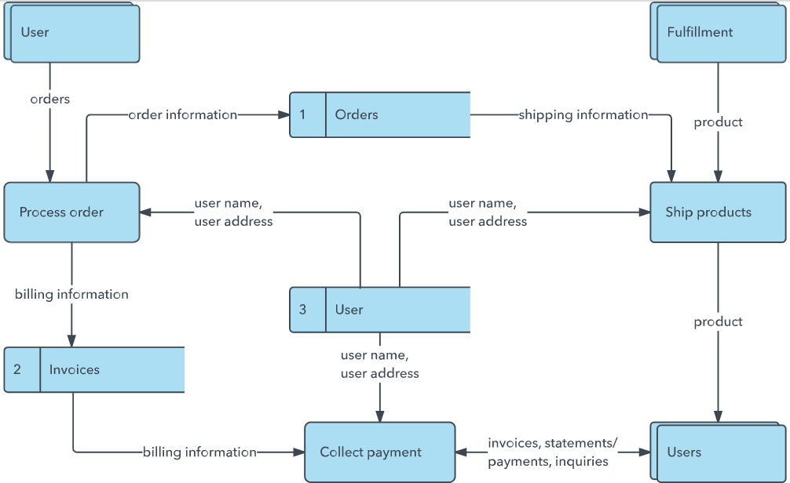

**Data Flow Diagram & User Stories**

|  |  |
| --- | --- |
| Date | 22 June 2025 |
| Team ID | LTVIP2025TMID30930 |
| Project Name | GARAGE MANAGEMENT SYSTEM |
| Maximum Marks | 4 Marks |

**Data Flow Diagrams:**

A Data Flow Diagram (DFD) is a traditional visual representation of the information flows within a system. A neat and clear DFD can depict the right amount of the system requirement graphically. It shows how data enters and leaves the system, what changes the information, and where data is stored.

Example: DFD Level 0 (Industry Standard)

**Example:** [**(Simplified)**](https://developer.ibm.com/patterns/visualize-unstructured-text/)

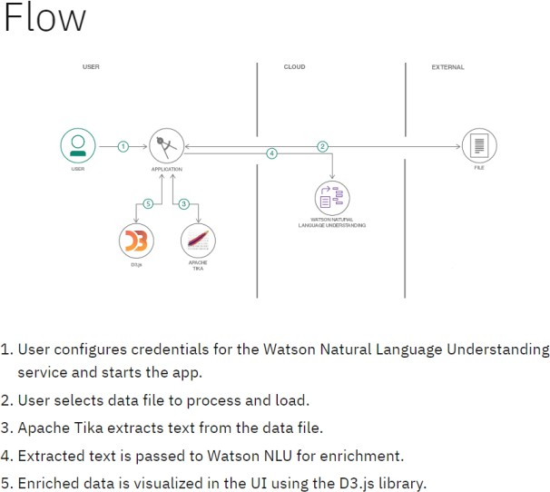

**User Stories**

Use the below template to list all the user stories for the product.

|  |  |  |  |  |  |  |
| --- | --- | --- | --- | --- | --- | --- |
| **User Type** | **Functional**  **Requirement (Epic)** | **User Story Number** | **User Story / Task** | **Acceptance criteria** | **Priority** | **Release** |
| Customer (Mobile user) | Registration | USN-1 | As a user, I can register for the application by entering my email, password, and confirming my password. | I can access my account / dashboard | High | Sprint-1 |
|  |  | USN-2 | As a user, I will receive confirmation email once I have registered for the application | I can receive confirmation email & click confirm | High | Sprint-1 |
|  |  | USN-3 | As a user, I can register for the application through Facebook | I can register & access the dashboard with Facebook  Login | Low | Sprint-2 |
|  |  | USN-4 | As a user, I can register for the application through Gmail |  | Medium | Sprint-1 |
|  | Login | USN-5 | As a user, I can log into the application by entering email & password |  | High | Sprint-1 |
|  | Dashboard |  |  |  |  |  |
| Customer (Web user) |  |  |  |  |  |  |
| Customer Care Executive |  |  |  |  |  |  |
| Administrator |  |  |  |  |  |  |
|  |  |  |  |  |  |  |
|  |  |  |  |  |  |  |
|  |  |  |  |  |  |  |

##### Project Design Phase-II

**Solution Requirements (Functional & Non-functional)**

|  |  |
| --- | --- |
| Date | 22 June 2025 |
| Team ID | LTVIP2025TMID30930 |
| Project Name | GARAGE MANAGEMENT SYSTEM |
| Maximum Marks | 4 Marks |

**Functional Requirements:**

Following are the functional requirements of the proposed solution.

|  |  |  |
| --- | --- | --- |
| **FR No.** | **Functional Requirement (Epic)** | **Sub Requirement (Story / Sub-Task)** |
| FR-1 | User Registration | Registration through Form Registration through Gmail Registration through LinkedIN |
| FR-2 | User Confirmation | Confirmation via Email  Confirmation via OTP |
| FR-3 |  |  |
| FR-4 |  |  |
|  |  |  |
|  |  |  |

**Non-functional Requirements:**

Following are the non-functional requirements of the proposed solution.

|  |  |  |
| --- | --- | --- |
| **FR No.** | **Non-Functional Requirement** | **Description** |
| NFR-1 | **Usability** |  |
| NFR-2 | **Security** |  |
| NFR-3 | **Reliability** |  |
| NFR-4 | **Performance** |  |
| NFR-5 | **Availability** |  |
| NFR-6 | **Scalability** |  |

##### Project Design Phase-II

**Solution Requirements (Functional & Non-functional)**

|  |  |
| --- | --- |
| Date | 22 June 2025 |
| Team ID | LTVIP2025TMID30930 |
| Project Name | GARAGE MANAGEMENT SYSTEM |
| Maximum Marks | 4 Marks |

**Functional Requirements:**

Following are the functional requirements of the proposed solution.

|  |  |  |
| --- | --- | --- |
| **FR No.** | **Functional Requirement (Epic)** | **Sub Requirement (Story / Sub-Task)** |
| FR-1 | User Registration | Registration through Form Registration through Gmail  Registration through LinkedIN |
| FR-2 | User Confirmation | Confirmation via Email Confirmation via OTP |
| FR-3 |  |  |
| FR-4 |  |  |
|  |  |  |
|  |  |  |

**Non-functional Requirements:**

Following are the non-functional requirements of the proposed solution.

|  |  |  |
| --- | --- | --- |
| **FR No.** | **Non-Functional Requirement** | **Description** |
| NFR-1 | **Usability** |  |
| NFR-2 | **Security** |  |
| NFR-3 | **Reliability** |  |
| NFR-4 | **Performance** |  |
| NFR-5 | **Availability** |  |
| NFR-6 | **Scalability** |  |

##### Project Design Phase-II Technology Stack (Architecture & Stack)

**Table-1 : Components & Technologies:**

|  |  |
| --- | --- |
| Date | 22 June 2025 |
| Team ID | LTVIP2025TMID30930 |
| Project Name | GARAGE MANAGEMENT SYSTEM |
| Maximum Marks | 4 Marks |

**Technical Architecture:**

The Deliverable shall include the architectural diagram as below and the information as per the table1 & table 2

**Example: Order processing during pandemics for offline mode**

**Reference:** [**https://developer.ibm.com/patterns/ai-powered-backend-system-for-order-processing-during-pandemics/**](https://developer.ibm.com/patterns/ai-powered-backend-system-for-order-processing-during-pandemics/)

|  |  |  |  |  |
| --- | --- | --- | --- | --- |
|  | | | Guidelines:  Include all the processes (As an application logic / Technology Block)  Provide infrastructural demarcation (Local / Cloud) Indicate external interfaces (third party API’s etc.) Indicate Data Storage components / services Indicate interface to machine learning models (if applicable) | |
| **S.No** | **Component** |  |
| **Description** | | **Technology** |

|  |  |  |  |
| --- | --- | --- | --- |
| 1. | User Interface | How user interacts with application e.g. Web UI, Mobile App, Chatbot etc. | HTML, CSS, JavaScript / Angular Js / React Js etc. |
| 2. | Application Logic-1 | Logic for a process in the application | Java / Python |
| 3. | Application Logic-2 | Logic for a process in the application | IBM Watson STT service |
| 4. | Application Logic-3 | Logic for a process in the application | IBM Watson Assistant |
| 5. | Database | Data Type, Configurations etc. | MySQL, NoSQL, etc. |
| 6. | Cloud Database | Database Service on Cloud | IBM DB2, IBM Cloudant etc. |
| 7. | File Storage | File storage requirements | IBM Block Storage or Other Storage Service or Local Filesystem |
| 8. | External API-1 | Purpose of External API used in the application | IBM Weather API, etc. |
| 9. | External API-2 | Purpose of External API used in the application | Aadhar API, etc. |
| 10. | Machine Learning Model | Purpose of Machine Learning Model | Object Recognition Model, etc. |
| 11. | Infrastructure (Server / Cloud) | Application Deployment on Local System / Cloud Local Server Configuration:  Cloud Server Configuration : | Local, Cloud Foundry, Kubernetes, etc. |

**Table-2: Application Characteristics:**

|  |  |  |  |
| --- | --- | --- | --- |
| **S.No** | **Characteristics** | **Description** | **Technology** |
| 1. | Open-Source Frameworks | List the open-source frameworks used | Technology of Opensource framework |
| 2. | Security Implementations | List all the security / access controls implemented, use of firewalls etc. | e.g. SHA-256, Encryptions, IAM Controls, OWASP etc. |
| 3. | Scalable Architecture | Justify the scalability of architecture (3 – tier,  Micro-services) | Technology used |
| 4. | Availability | Justify the availability of application (e.g. use of load balancers, distributed servers etc.) | Technology used |

|  |  |  |  |
| --- | --- | --- | --- |
| **S.No** | **Characteristics** | **Description** | **Technology** |
| 5. | Performance | Design consideration for the performance of the application (number of requests per sec, use of Cache, use of CDN’s) etc. | Technology used |

**References:**

[**https://c4model.com/**](https://c4model.com/)

[**https://developer.ibm.com/patterns/online-order-processing-system-during-pandemic/**](https://developer.ibm.com/patterns/online-order-processing-system-during-pandemic/)[**https://www.ibm.com/cloud/architecture**](https://www.ibm.com/cloud/architecture)

[**https://aws.amazon.com/architecture**](https://aws.amazon.com/architecture)

[**https://medium.com/the-internal-startup/how-to-draw-useful-technical-architecture-diagrams-2d20c9fda90d**](https://medium.com/the-internal-startup/how-to-draw-useful-technical-architecture-diagrams-2d20c9fda90d)

##### Project Design Phase-II Technology Stack (Architecture & Stack)

|  |  |
| --- | --- |
| Date | 22 June 2025 |
| Team ID | LTVIP2025TMID30930 |
| Project Name | GARAGE MANAGEMENT SYSTEM |
| Maximum Marks | 4 Marks |

**Technical Architecture:**

The Deliverable shall include the architectural diagram as below and the information as per the table1 & table 2

**Example: Order processing during pandemics for offline mode**

**Reference:** [**https://developer.ibm.com/patterns/ai-powered-backend-system-for-order-processing-during-pandemics/**](https://developer.ibm.com/patterns/ai-powered-backend-system-for-order-processing-during-pandemics/)

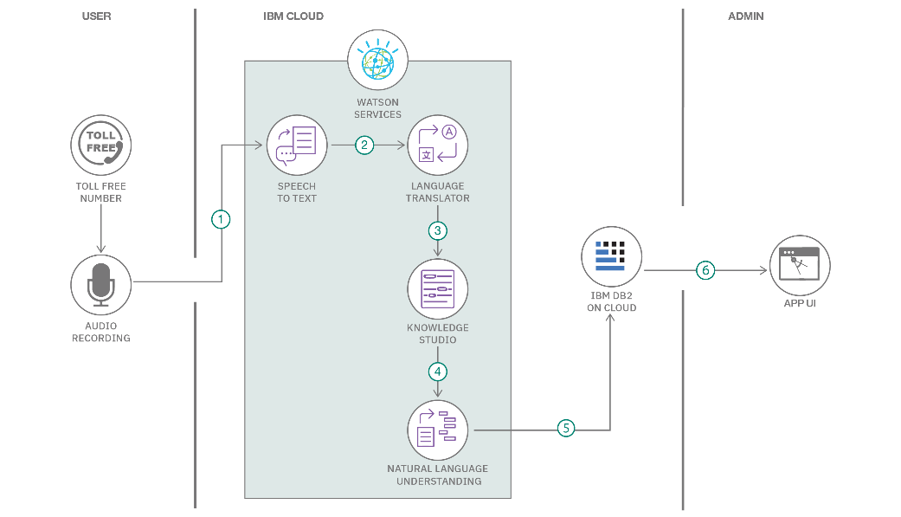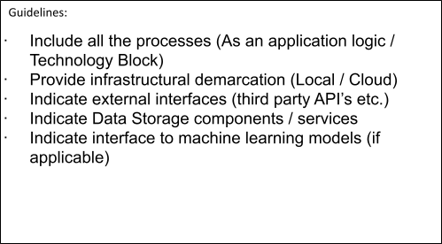

**Table-1 : Components & Technologies:**

|  |  |  |  |
| --- | --- | --- | --- |
| **S.No** | **Component** | **Description** | **Technology** |
| 1. | User Interface | How user interacts with application e.g. Web UI, Mobile App, Chatbot etc. | HTML, CSS, JavaScript / Angular Js / React Js etc. |

|  |  |  |  |
| --- | --- | --- | --- |
| 2. | Application Logic-1 | Logic for a process in the application | Java / Python |
| 3. | Application Logic-2 | Logic for a process in the application | IBM Watson STT service |
| 4. | Application Logic-3 | Logic for a process in the application | IBM Watson Assistant |
| 5. | Database | Data Type, Configurations etc. | MySQL, NoSQL, etc. |
| 6. | Cloud Database | Database Service on Cloud | IBM DB2, IBM Cloudant etc. |
| 7. | File Storage | File storage requirements | IBM Block Storage or Other Storage Service or Local Filesystem |
| 8. | External API-1 | Purpose of External API used in the application | IBM Weather API, etc. |
| 9. | External API-2 | Purpose of External API used in the application | Aadhar API, etc. |
| 10. | Machine Learning Model | Purpose of Machine Learning Model | Object Recognition Model, etc. |
| 11. | Infrastructure (Server / Cloud) | Application Deployment on Local System / Cloud Local Server Configuration:  Cloud Server Configuration : | Local, Cloud Foundry, Kubernetes, etc. |

**Table-2: Application Characteristics:**

|  |  |  |  |
| --- | --- | --- | --- |
| **S.No** | **Characteristics** | **Description** | **Technology** |
| 1. | Open-Source Frameworks | List the open-source frameworks used | Technology of Opensource framework |
| 2. | Security Implementations | List all the security / access controls implemented, use of firewalls etc. | e.g. SHA-256, Encryptions, IAM Controls, OWASP etc. |
| 3. | Scalable Architecture | Justify the scalability of architecture (3 – tier, Micro-services) | Technology used |
| 4. | Availability | Justify the availability of application (e.g. use of load balancers, distributed servers etc.) | Technology used |

|  |  |  |  |
| --- | --- | --- | --- |
| **S.No** | **Characteristics** | **Description** | **Technology** |
| 5. | Performance | Design consideration for the performance of the application (number of requests per sec, use of Cache, use of CDN’s) etc. | Technology used |

**References:**

[**https://c4model.com/**](https://c4model.com/)

[**https://developer.ibm.com/patterns/online-order-processing-system-during-pandemic/**](https://developer.ibm.com/patterns/online-order-processing-system-during-pandemic/)[**https://www.ibm.com/cloud/architecture**](https://www.ibm.com/cloud/architecture)

[**https://aws.amazon.com/architecture**](https://aws.amazon.com/architecture)

[**https://medium.com/the-internal-startup/how-to-draw-useful-technical-architecture-diagrams-2d20c9fda90d**](https://medium.com/the-internal-startup/how-to-draw-useful-technical-architecture-diagrams-2d20c9fda90d)

**Project Report Format**

1. **INTRODUCTION**
   1. Project Overview
   2. Purpose
2. **IDEATION PHASE**
   1. Problem Statement
   2. Empathy Map Canvas
   3. Brainstorming
3. **REQUIREMENT ANALYSIS**
   1. Customer Journey map
   2. Solution Requirement
   3. Data Flow Diagram
   4. Technology Stack
4. **PROJECT DESIGN**
   1. Problem Solution Fit
   2. Proposed Solution
   3. Solution Architecture
5. **PROJECT PLANNING & SCHEDULING**
   1. Project Planning
6. **FUNCTIONAL AND PERFORMANCE TESTING**
   1. Performance Testing
7. **RESULTS**
   1. Output Screenshots
8. **ADVANTAGES & DISADVANTAGES**
9. **CONCLUSION**
10. **FUTURE SCOPE**
11. **APPENDIX**

Source Code(if any) Dataset Link

GitHub & Project Demo Link

# Full Stack Development with MERN Project Documentation format

### Introduction

* + **Project Title:** [Your Project Title]
  + **Team Members:** List team members and their roles.

### Project Overview

* + **Purpose:** Briefly describe the purpose and goals of the project.
  + **Features:** Highlight key features and functionalities.

### Architecture

* + **Frontend:** Describe the frontend architecture using React.
  + **Backend:** Outline the backend architecture using Node.js and Express.js.
  + **Database:** Detail the database schema and interactions with MongoDB.

### Setup Instructions

* + **Prerequisites:** List software dependencies (e.g., Node.js, MongoDB).
  + **Installation:** Step-by-step guide to clone, install dependencies, and set up the environment variables.

### Folder Structure

* + **Client:** Describe the structure of the React frontend.
  + **Server:** Explain the organization of the Node.js backend.

### Running the Application

* + Provide commands to start the frontend and backend servers locally.
    - **Frontend:** npm start in the client directory.
    - **Backend:** npm start in the server directory.

### API Documentation

* + Document all endpoints exposed by the backend.
  + Include request methods, parameters, and example responses.

### Authentication

* + Explain how authentication and authorization are handled in the project.
  + Include details about tokens, sessions, or any other methods used.

### User Interface

* + Provide screenshots or GIFs showcasing different UI features.

### Testing

* + Describe the testing strategy and tools used.

### Screenshots or Demo

* + Provide screenshots or a link to a demo to showcase the application.

### Known Issues

* + Document any known bugs or issues that users or developers should be aware of.

### Future Enhancements

* + Outline potential future features or improvements that could be made to the project.